

**University database**

Created by Usama Asad

**Report**

**Content**

1. Abstract
2. Introduction
3. Methods Used
4. Tables
5. Queries
6. Data Retrieve
7. Entity Relationship Diagram
8. Normalization to 3NF
9. PL functions
10. References

Abstract**:**

This university database serves as a central repository for managing various aspects of university operations, including student information, course offerings, faculty data, administrative processes, and resources. It provides a structured and unified platform for data storage, retrieval, and manipulation, facilitating efficient administration, academic activities, and student support services.

Introduction:

A university database plays a crucial role in the smooth functioning of a modern educational institution. It acts as the backbone for various critical systems, centralizing information and streamlining processes. This introduction delves into the key components and functionalities of a university database:

* **Student Information:** The database stores comprehensive student data, including demographics, academic records (courses taken, grades earned, transcripts), registration details, and financial aid information. This data allows for efficient student management, tracking academic progress, and facilitating communication.
* **Course Management:** The system stores information about courses offered, including course descriptions, prerequisites, instructors, schedules, and enrollment data. This enables effective course planning, registration management, and generation of academic reports.
* **Faculty Data:** The database houses faculty information such as profiles, contact details, research interests, and teaching assignments. This data facilitates faculty management, communication with instructors, and course allocation based on expertise.
* **Administrative Processes:** The system supports various administrative functions like admissions processing, application management, financial aid disbursement, and transcript issuing. This streamlines workflows, improves decision-making, and enhances service delivery to students.
* **Resources and Services:** The database can be integrated with systems managing university resources, such as library materials, IT support services, and campus security. This enhances resource allocation, user access management, and facilitates communication regarding available services.

# Methods Used

1. Create Table
2. Create Database
3. Select Statement
4. Procedures

# Tables Used:

1. Student
2. Faculty
3. Course
4. Administrator
5. Department
6. ResearchLab
7. Program
8. Admissions_Office
9. Registrar_Office
10. Financial_Aid_Office
11. Libraries
12. Campus_Security
13. IT_Department

### QUERIES

### CREATE TABLE AND DATABASE

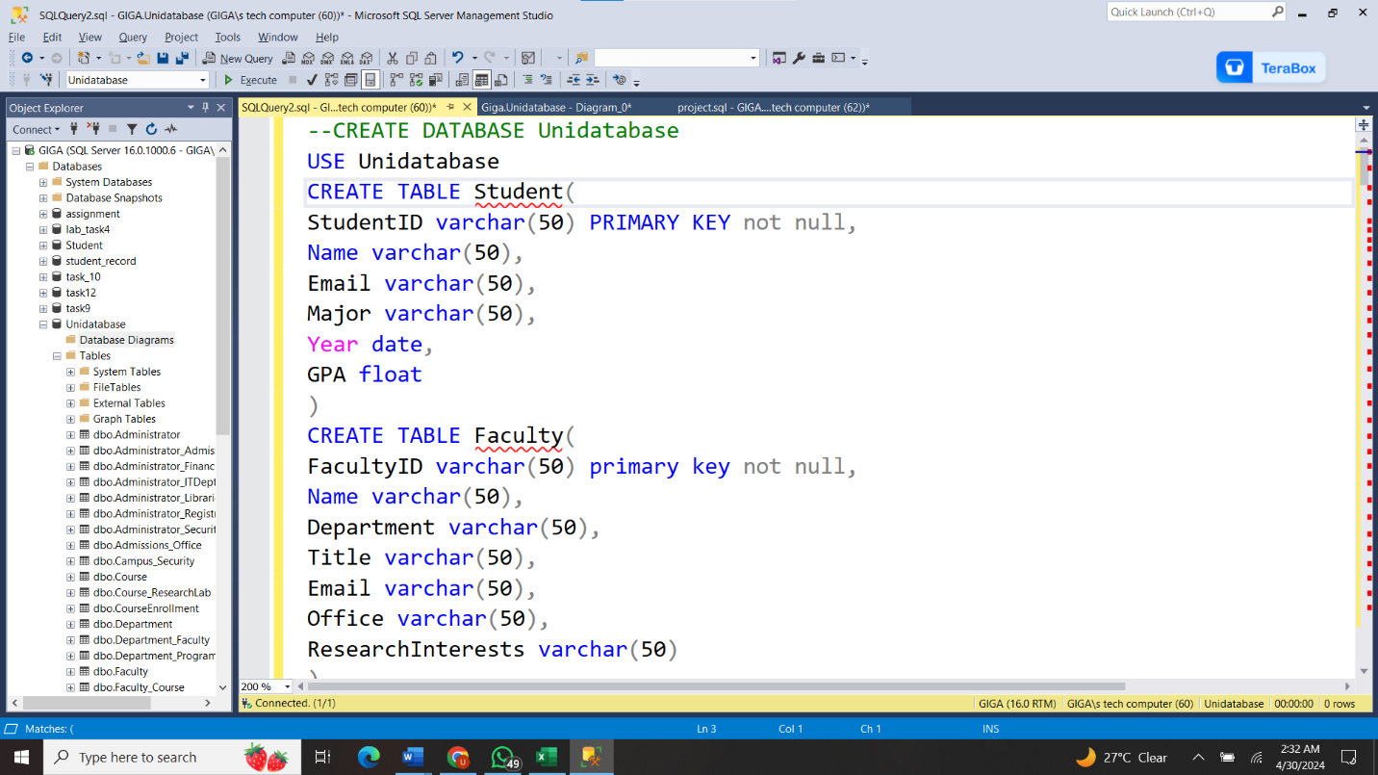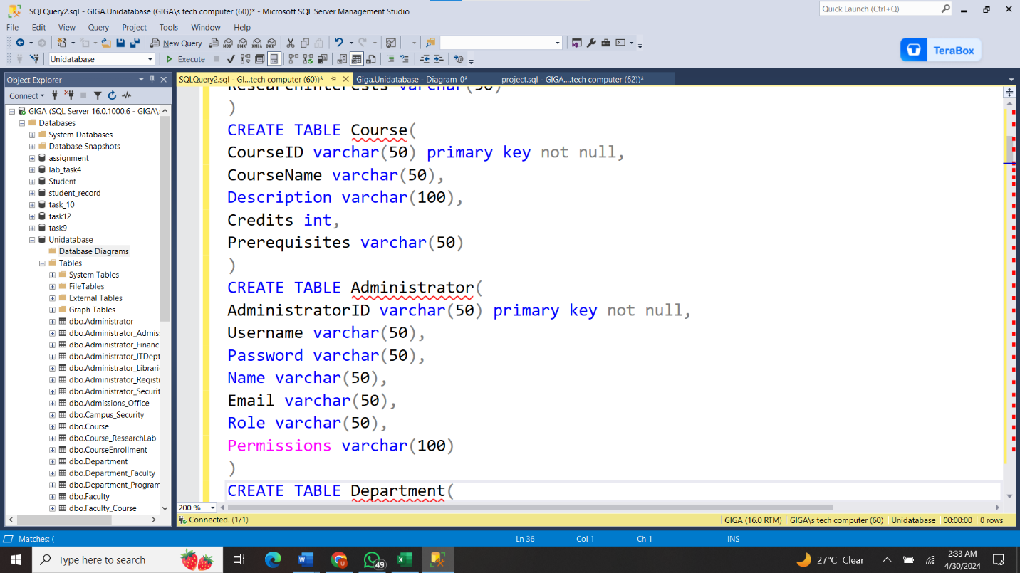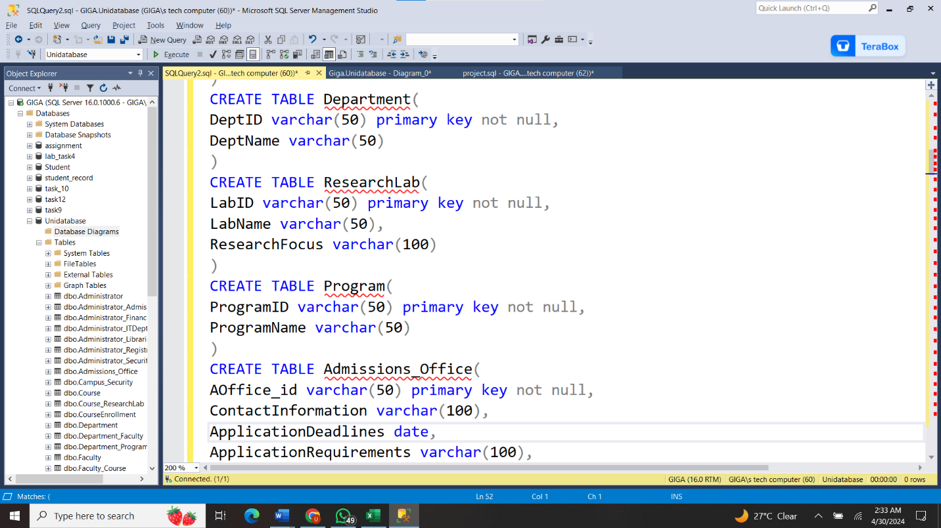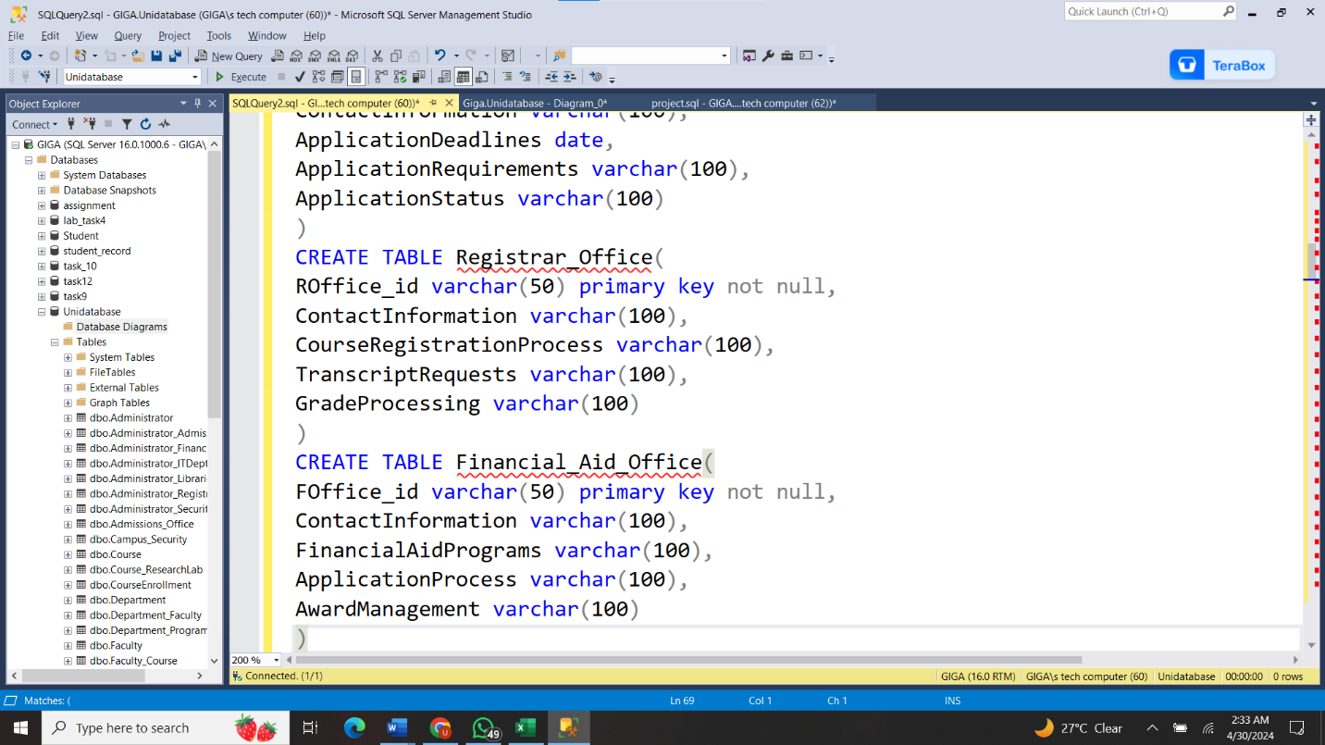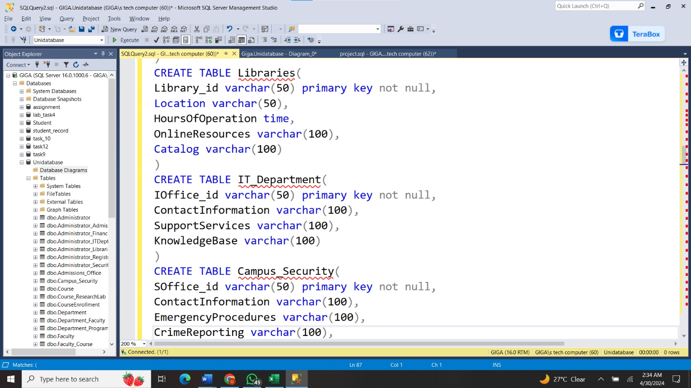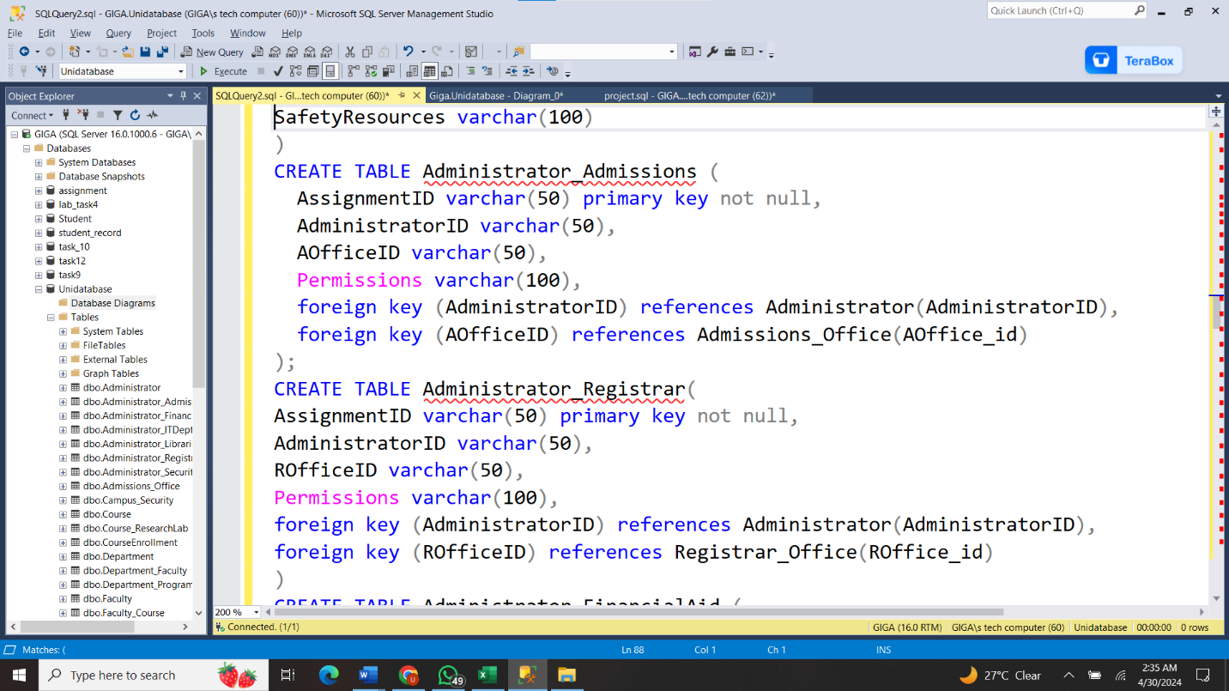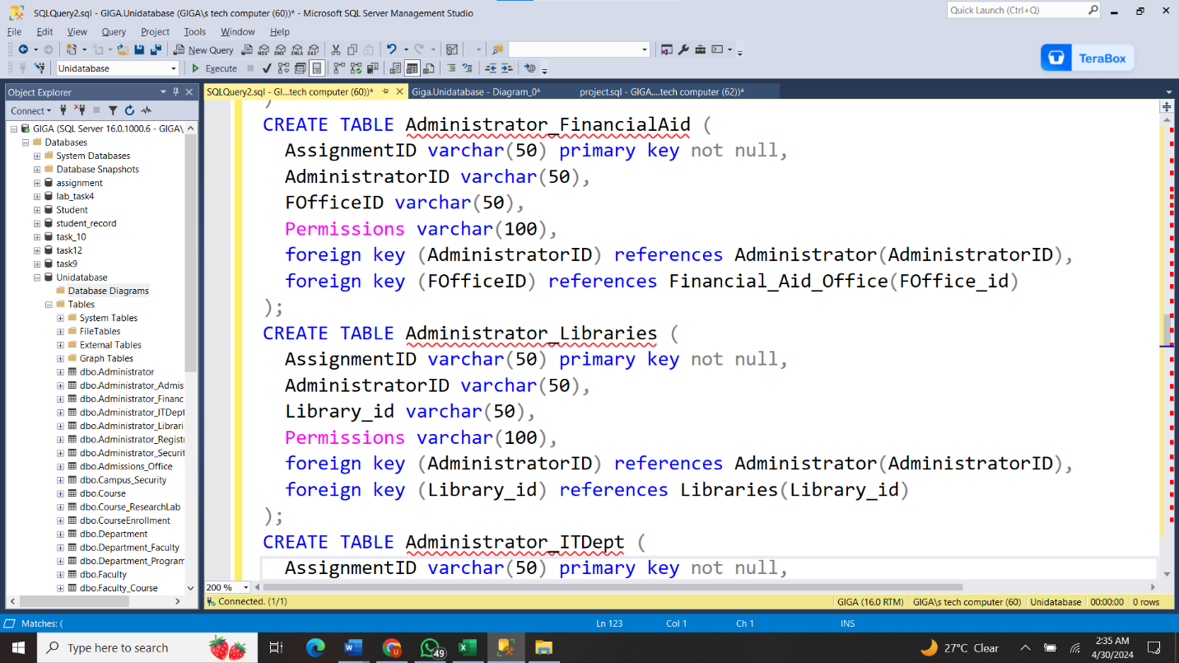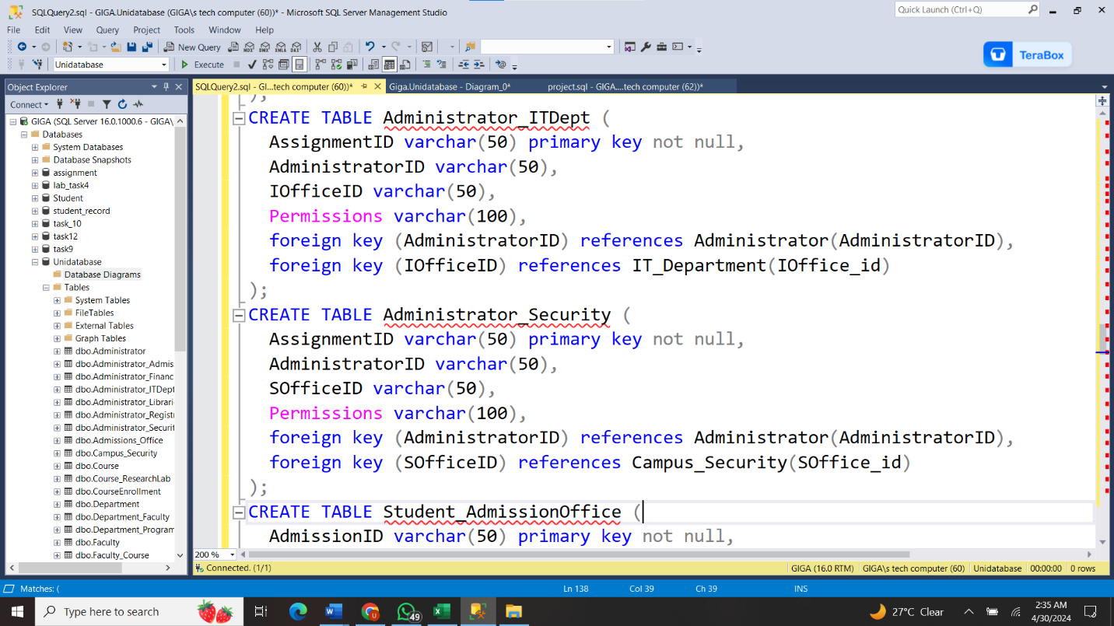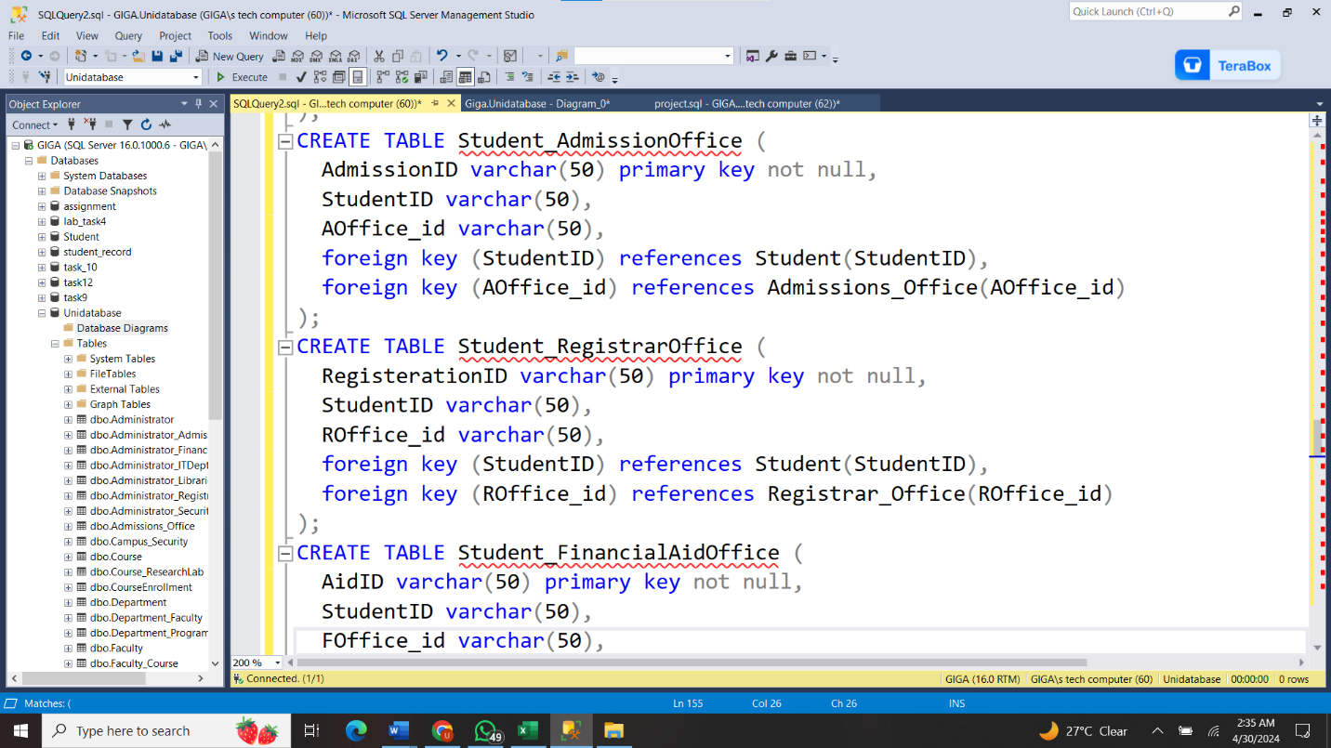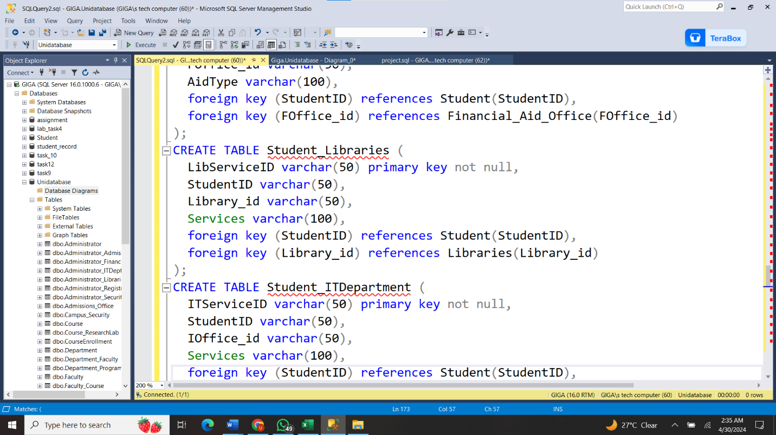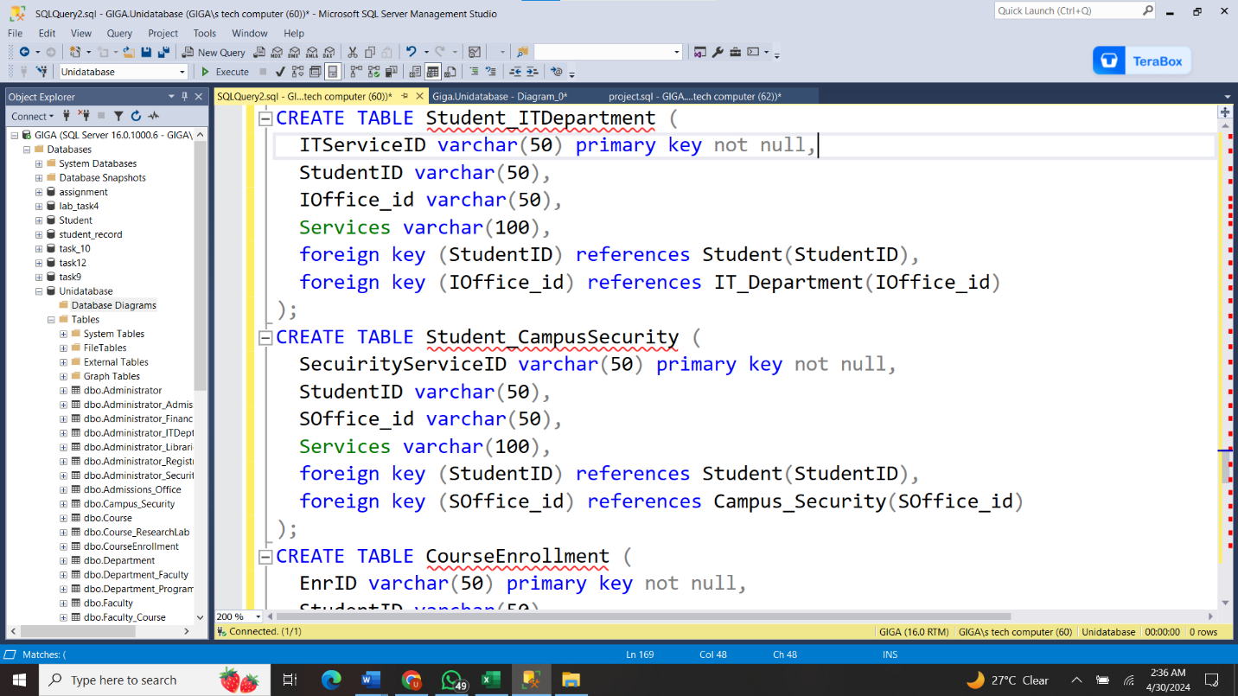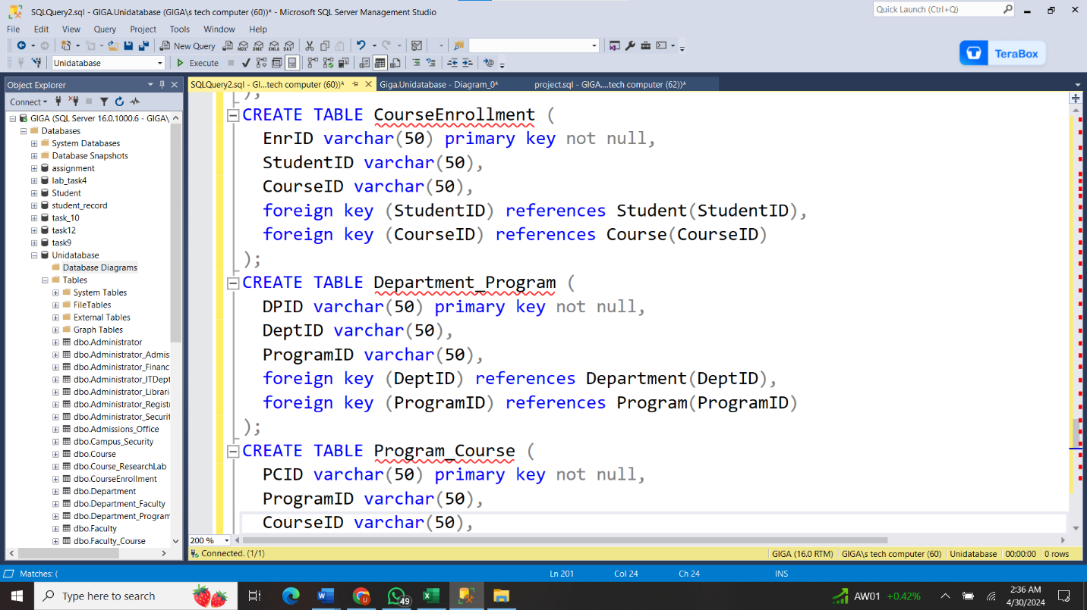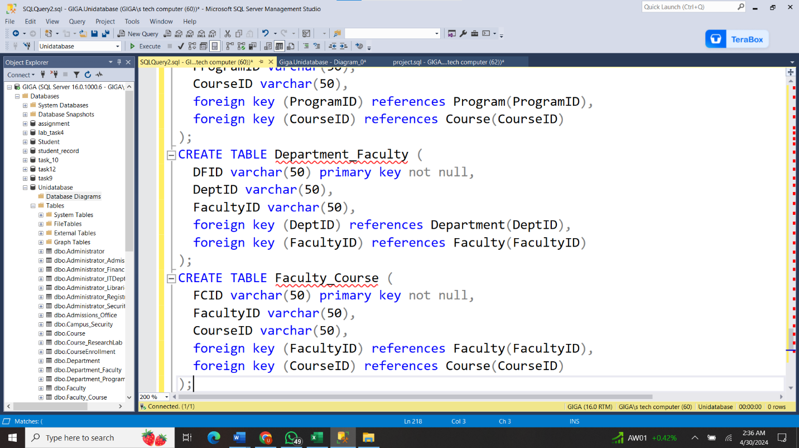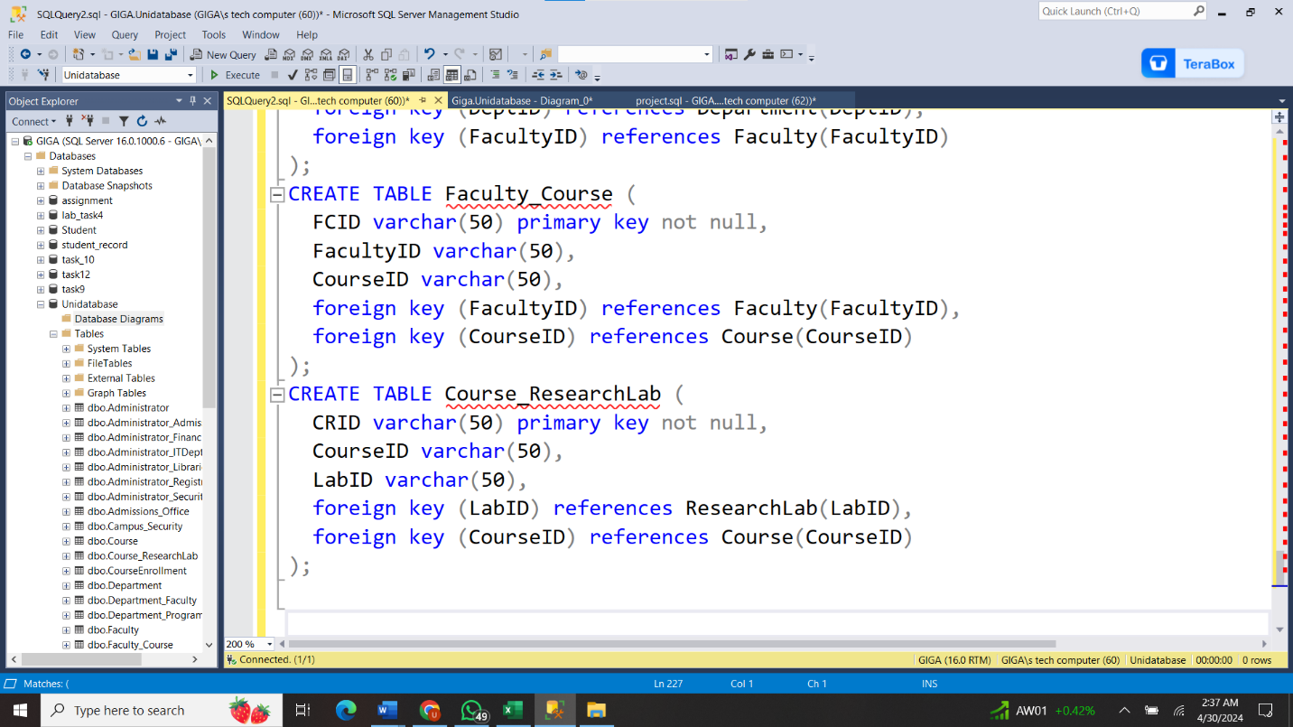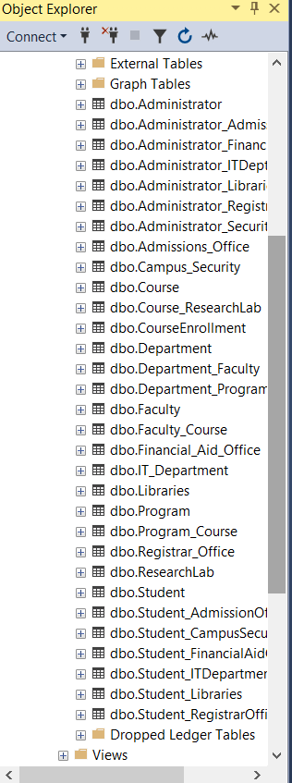

### INSERT DATA

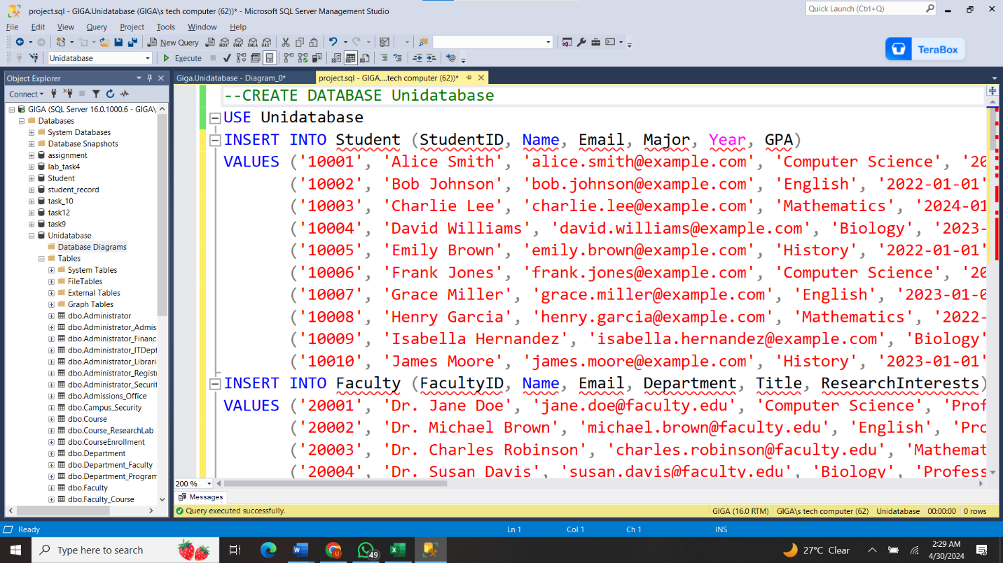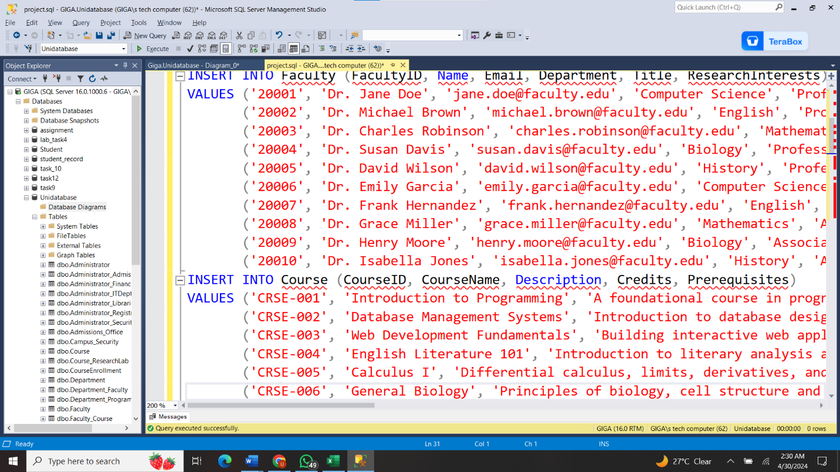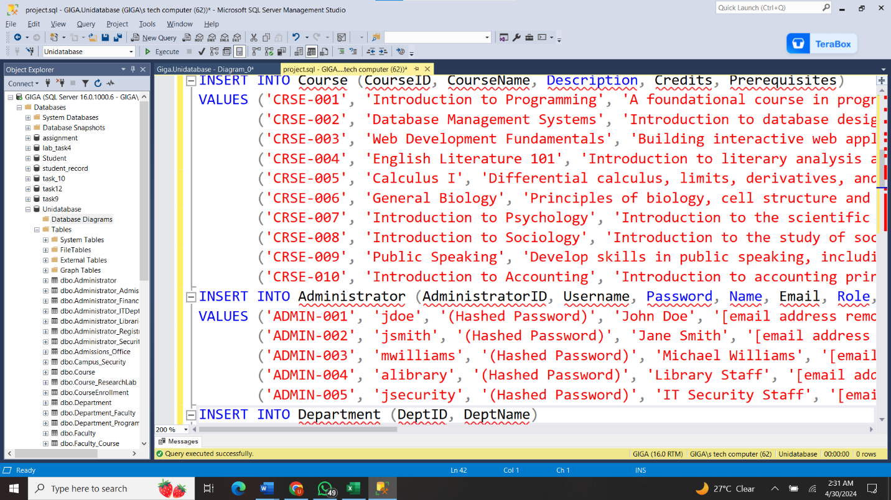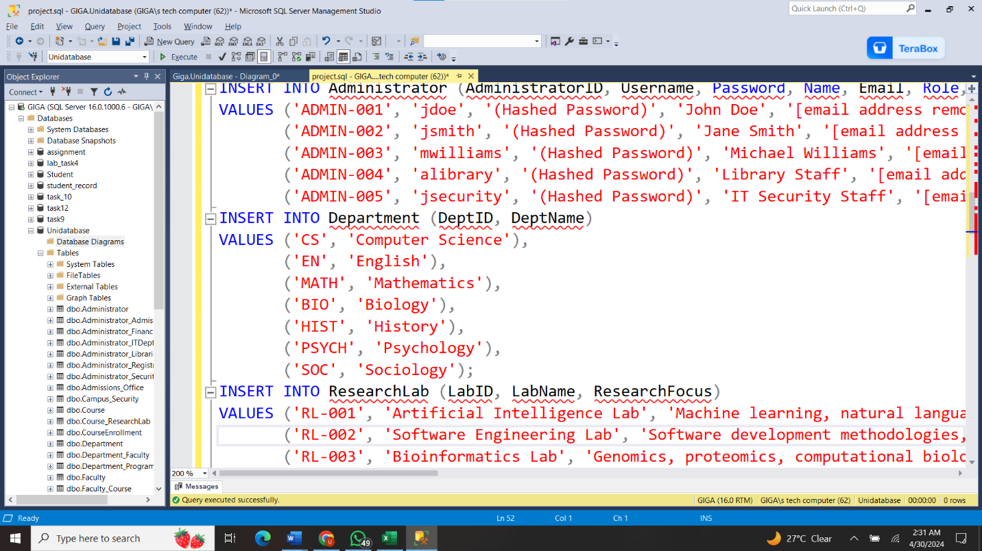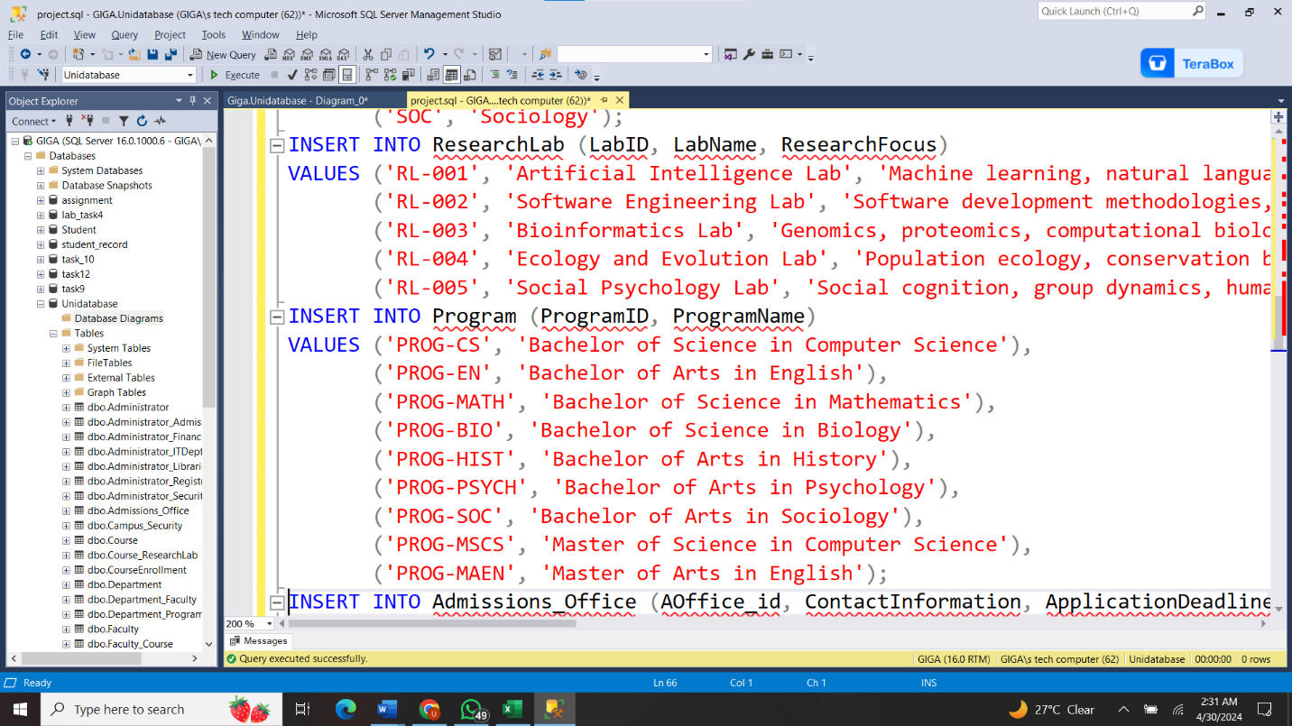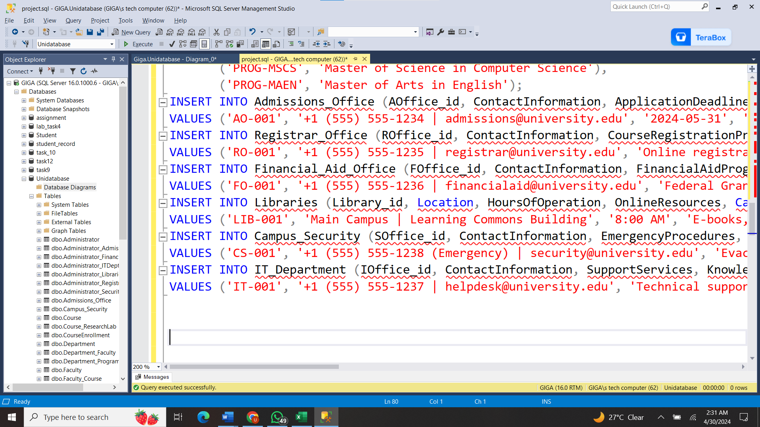

# Data Retrieve:

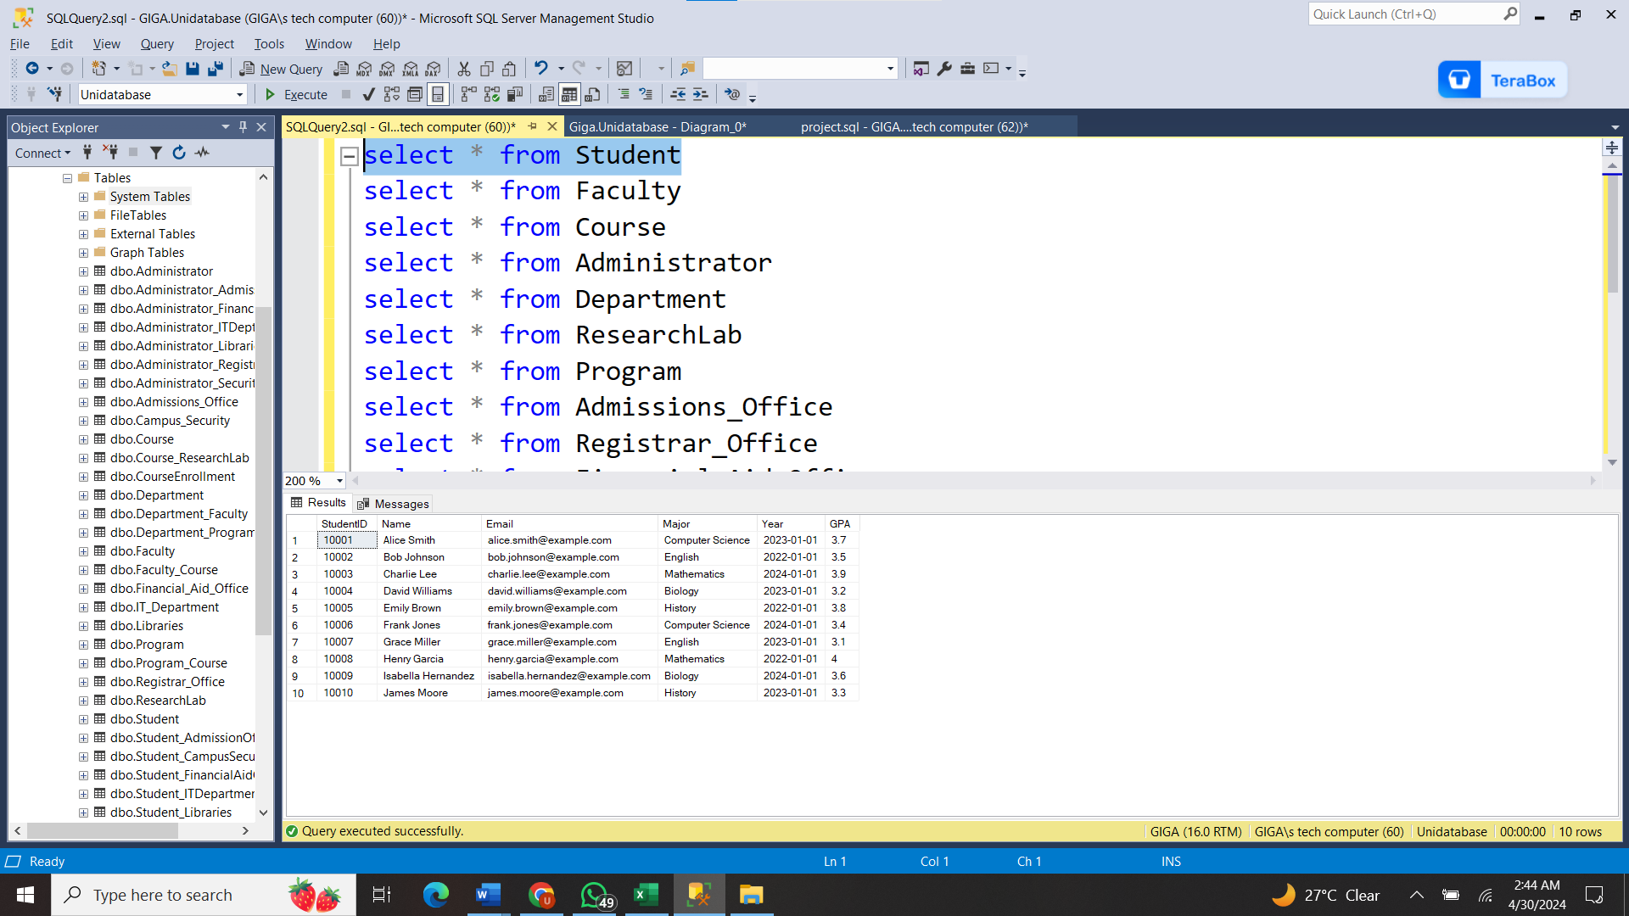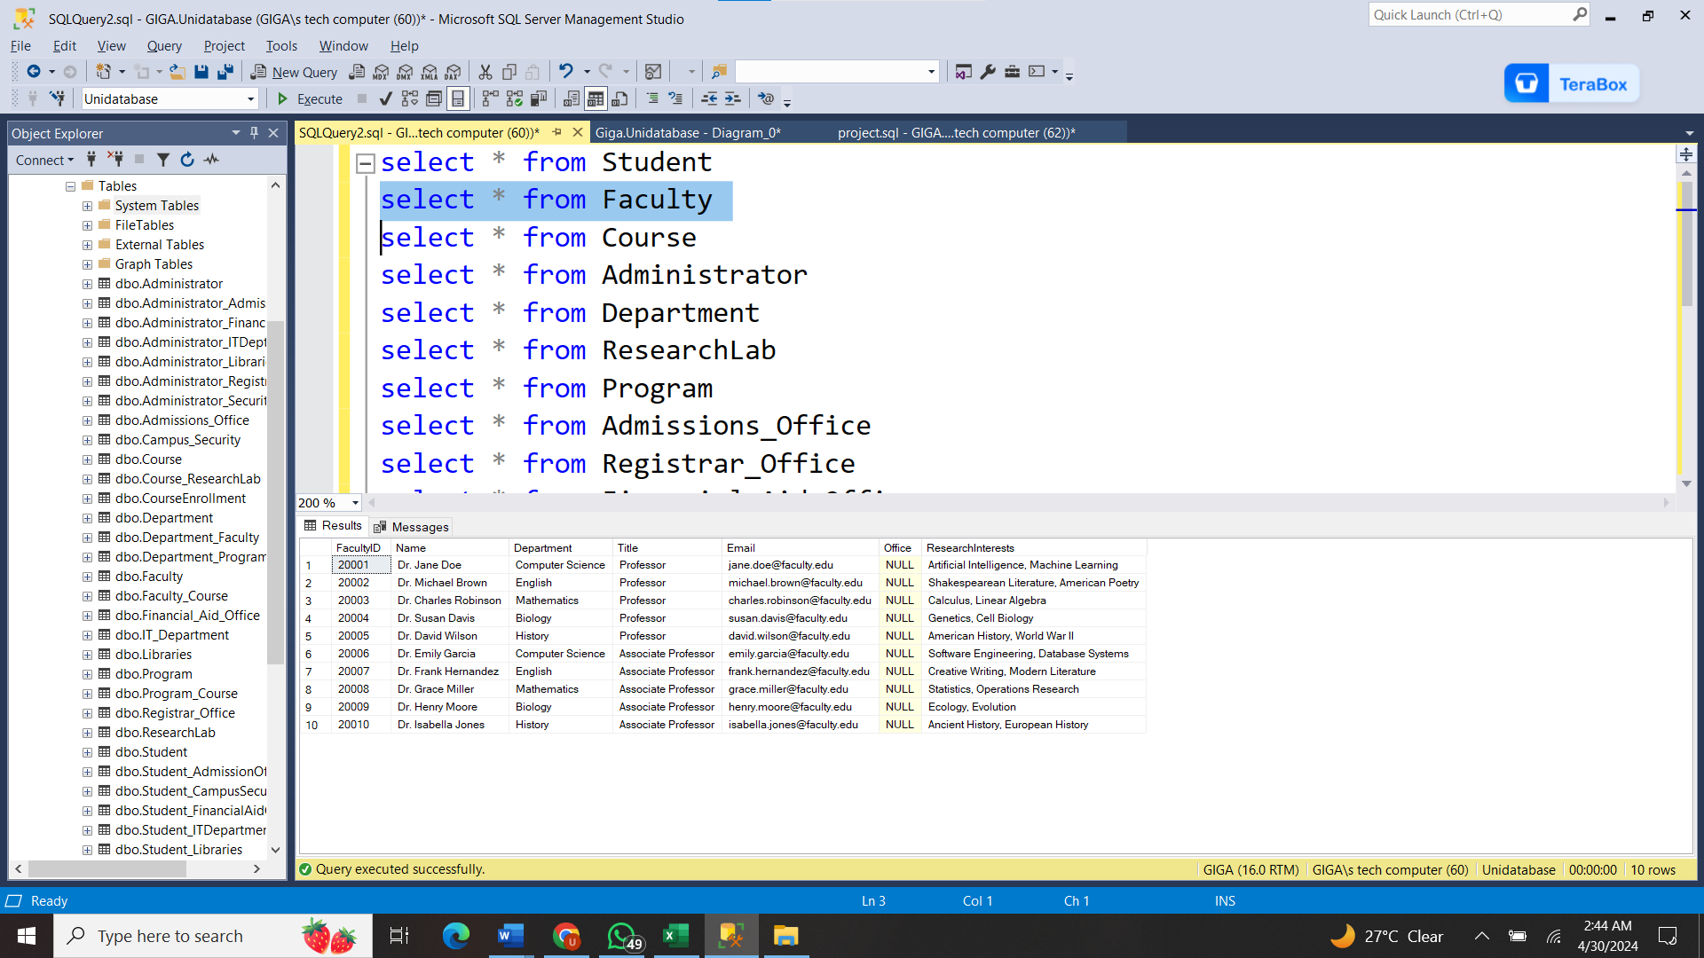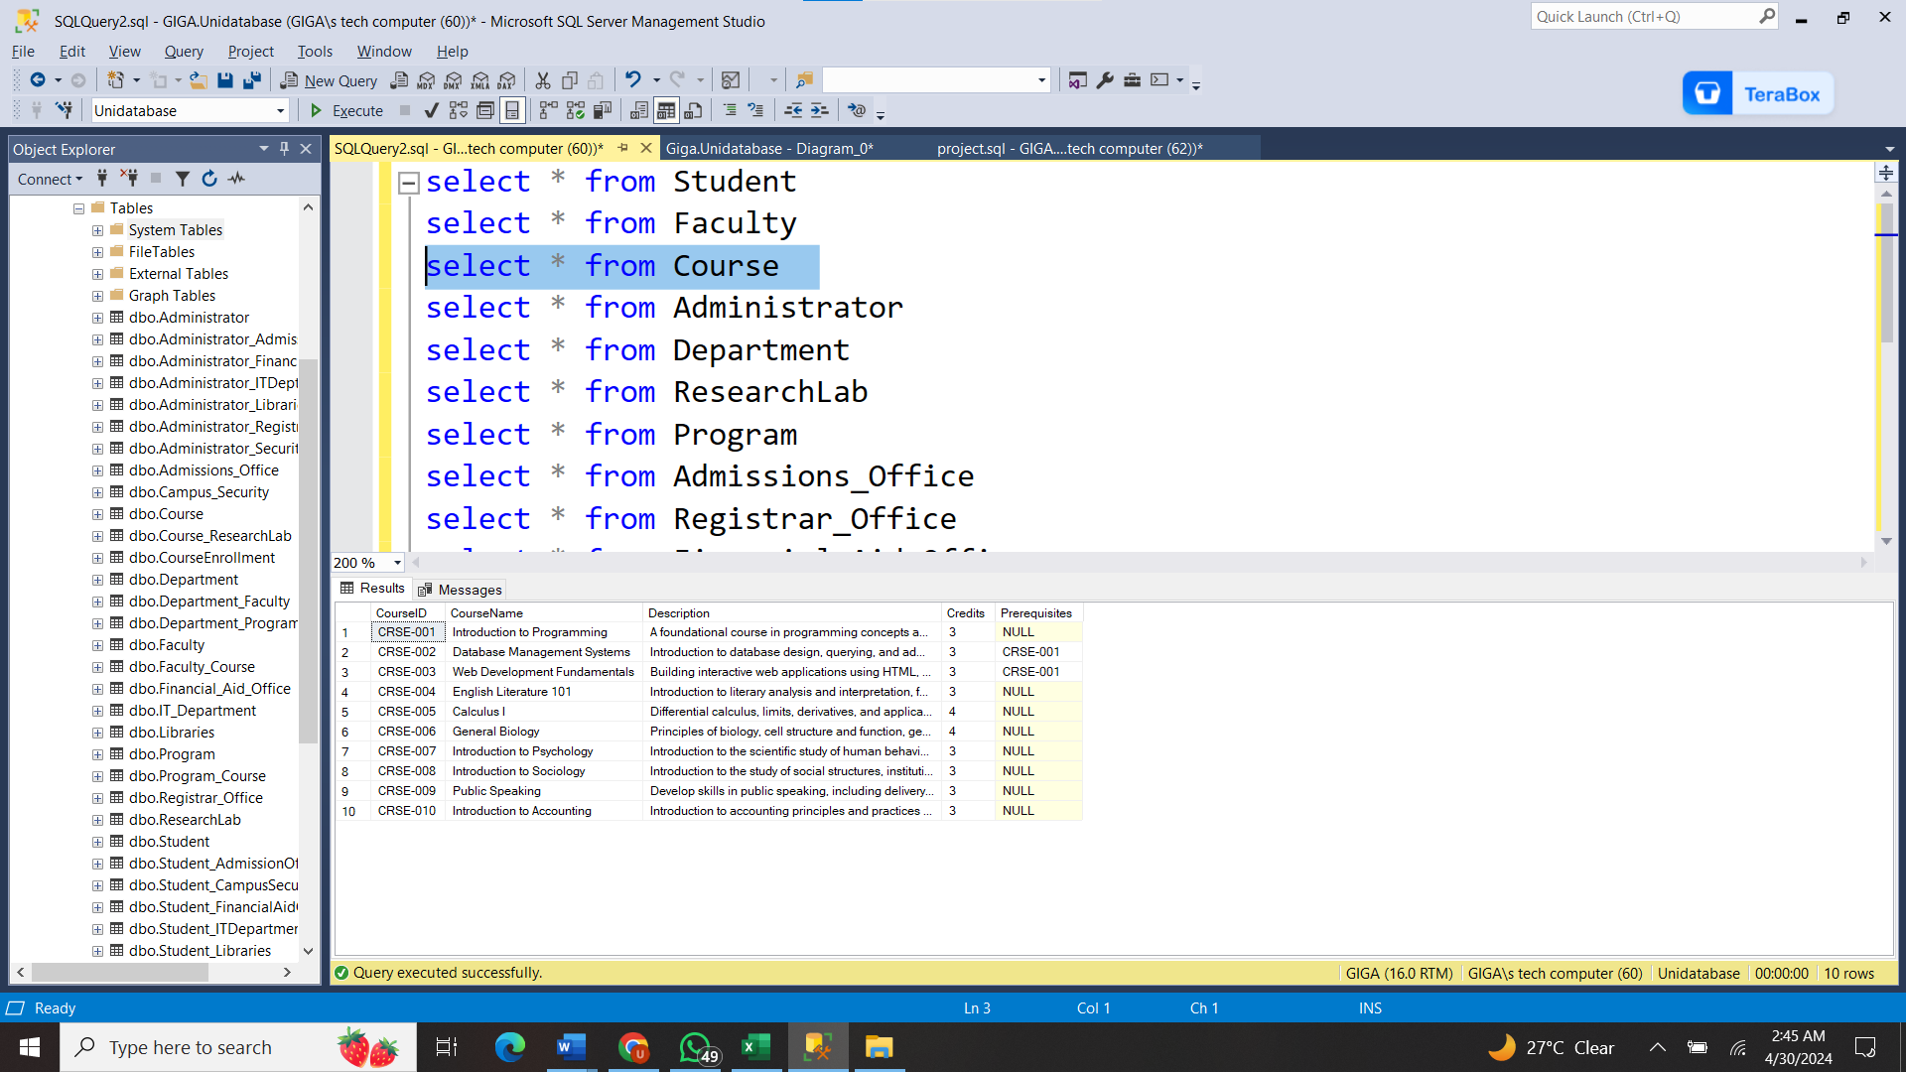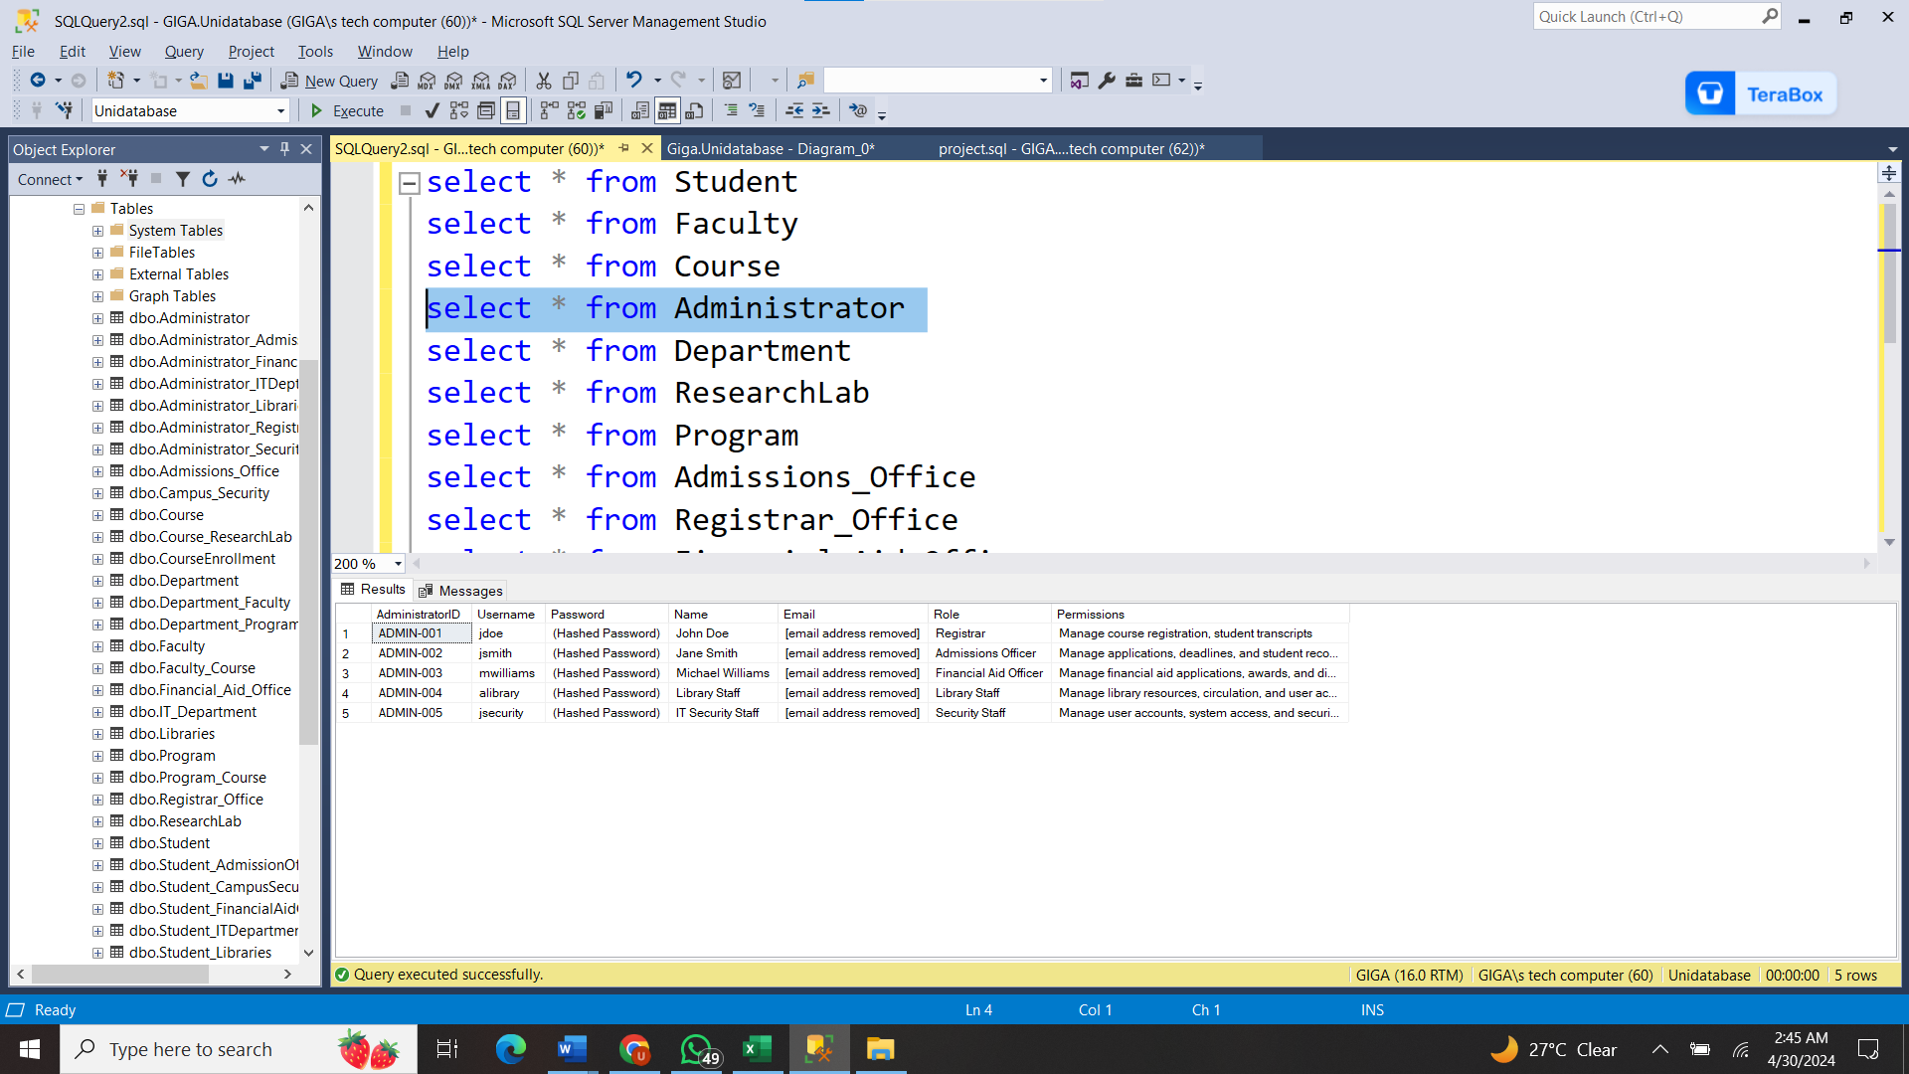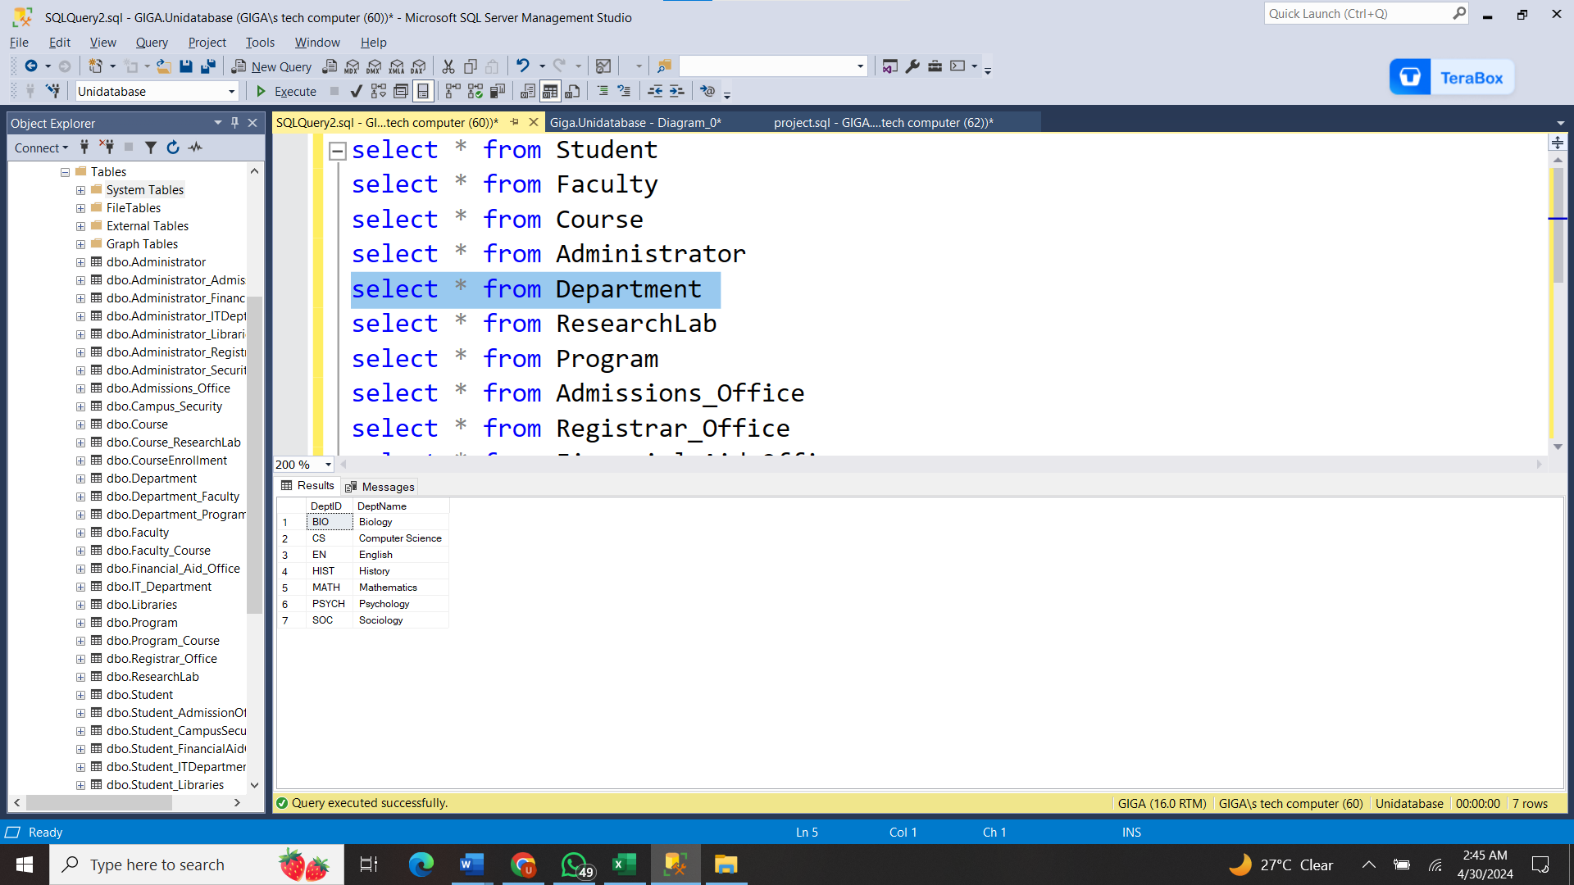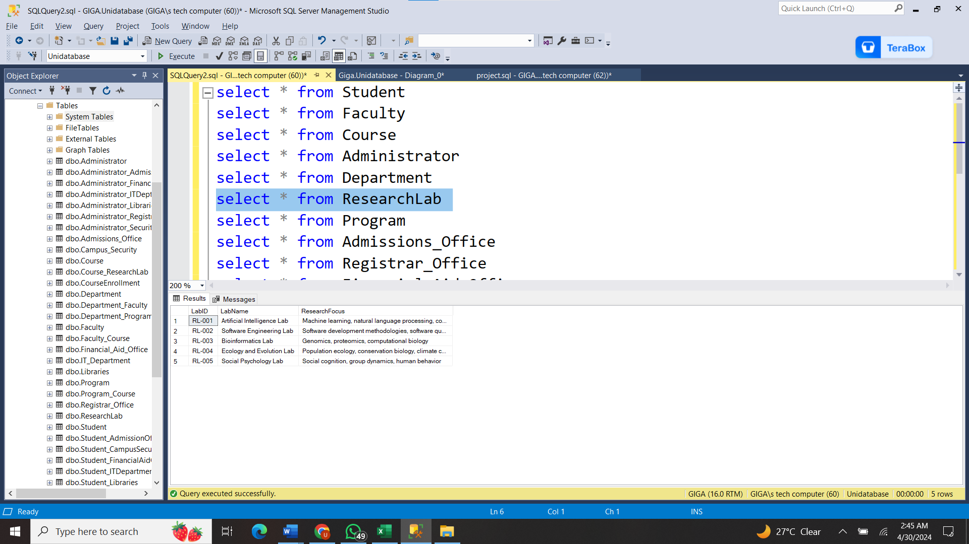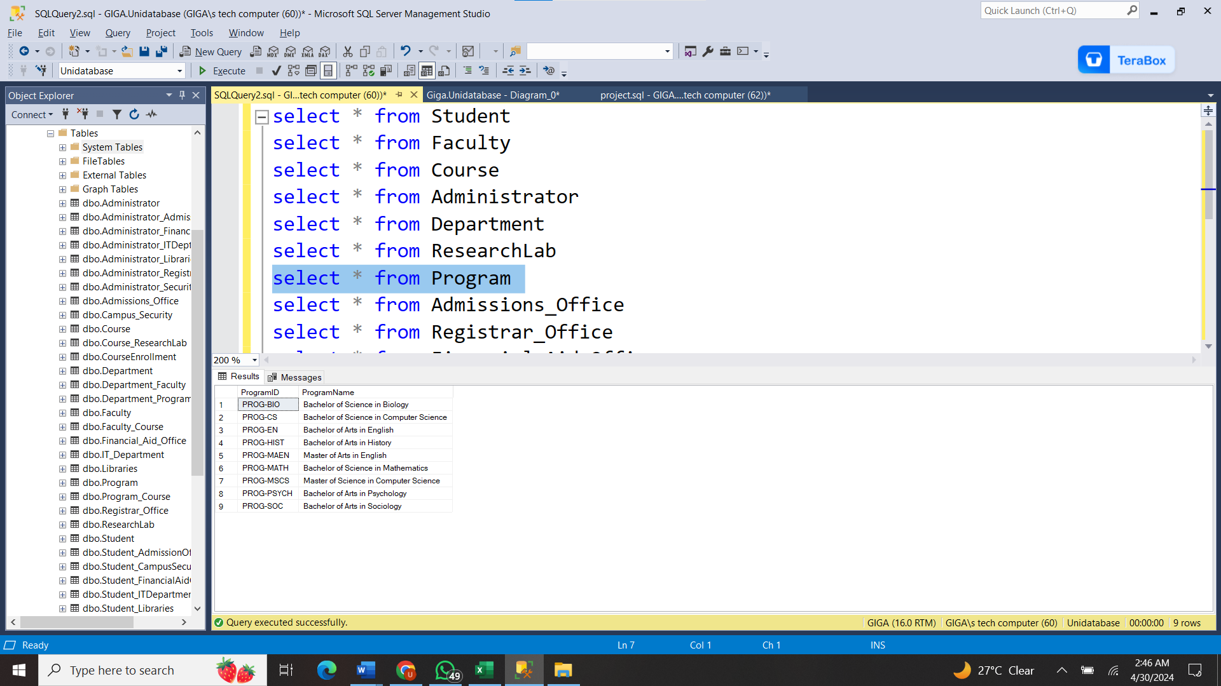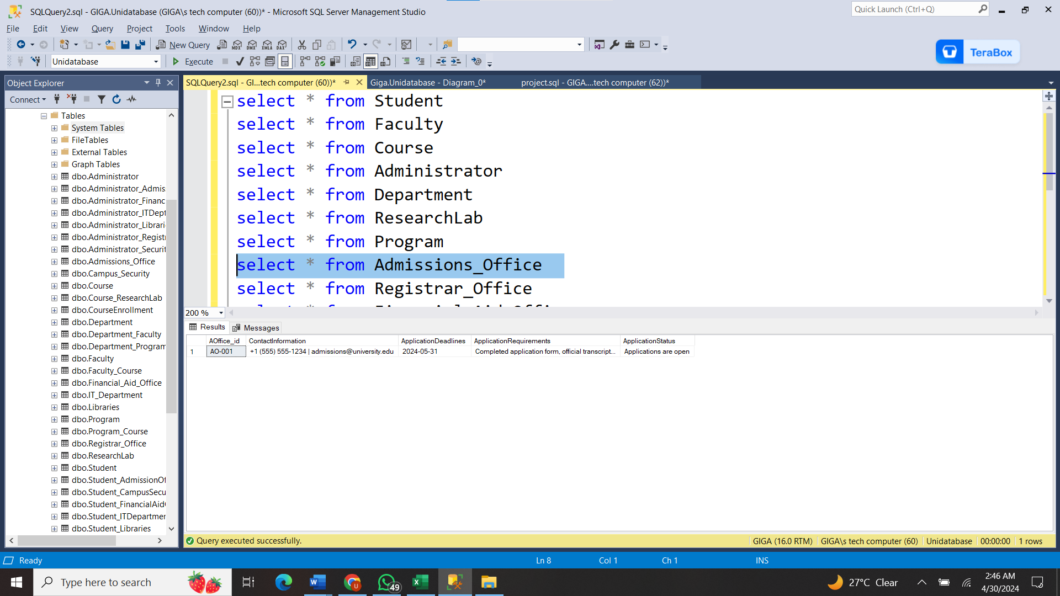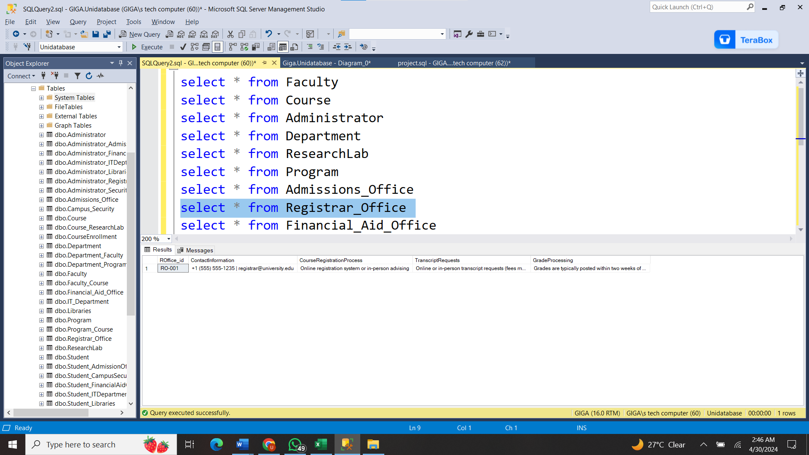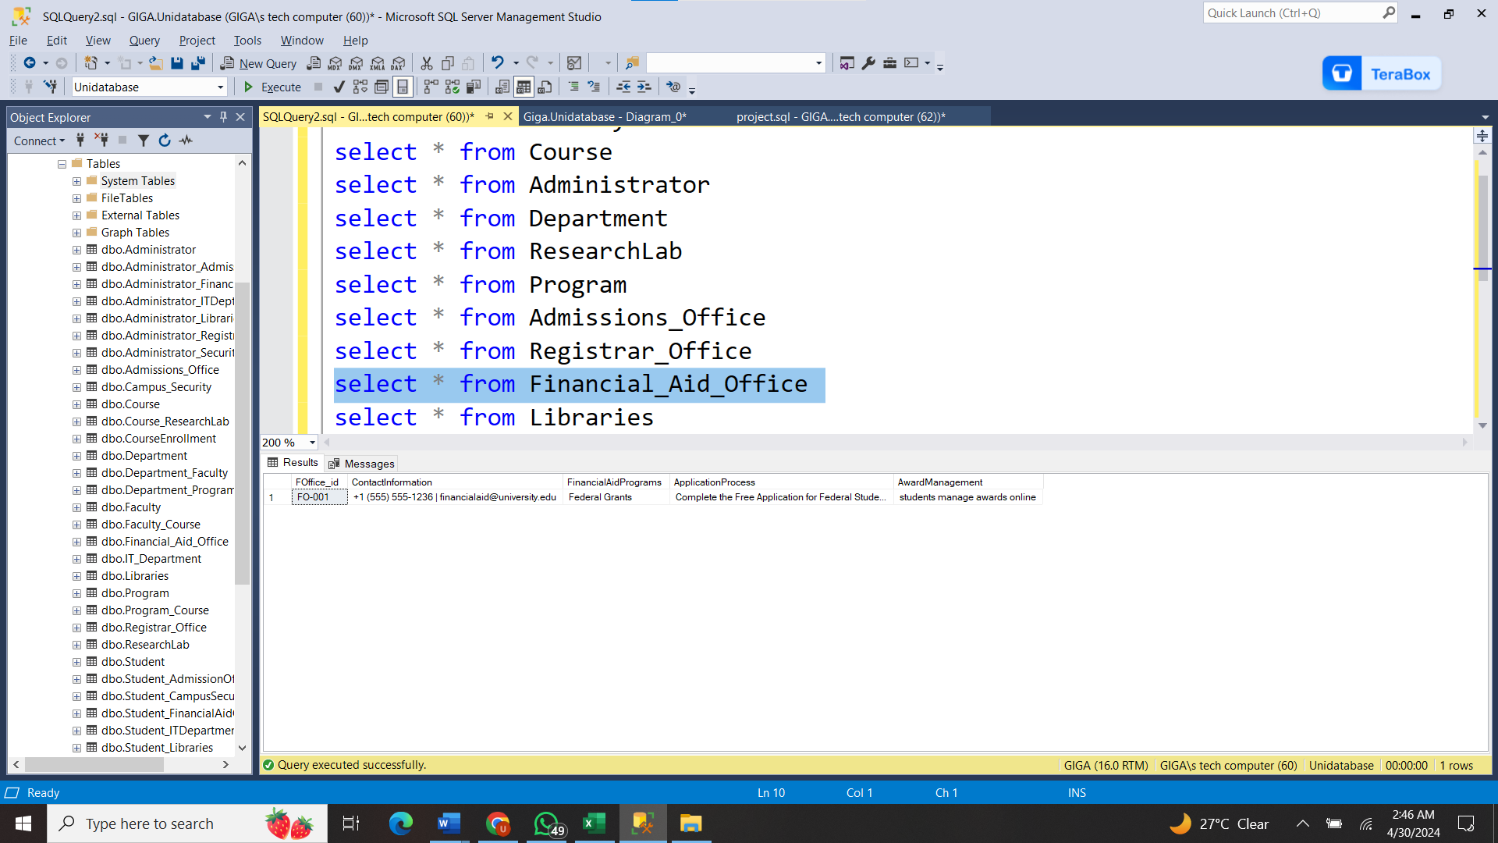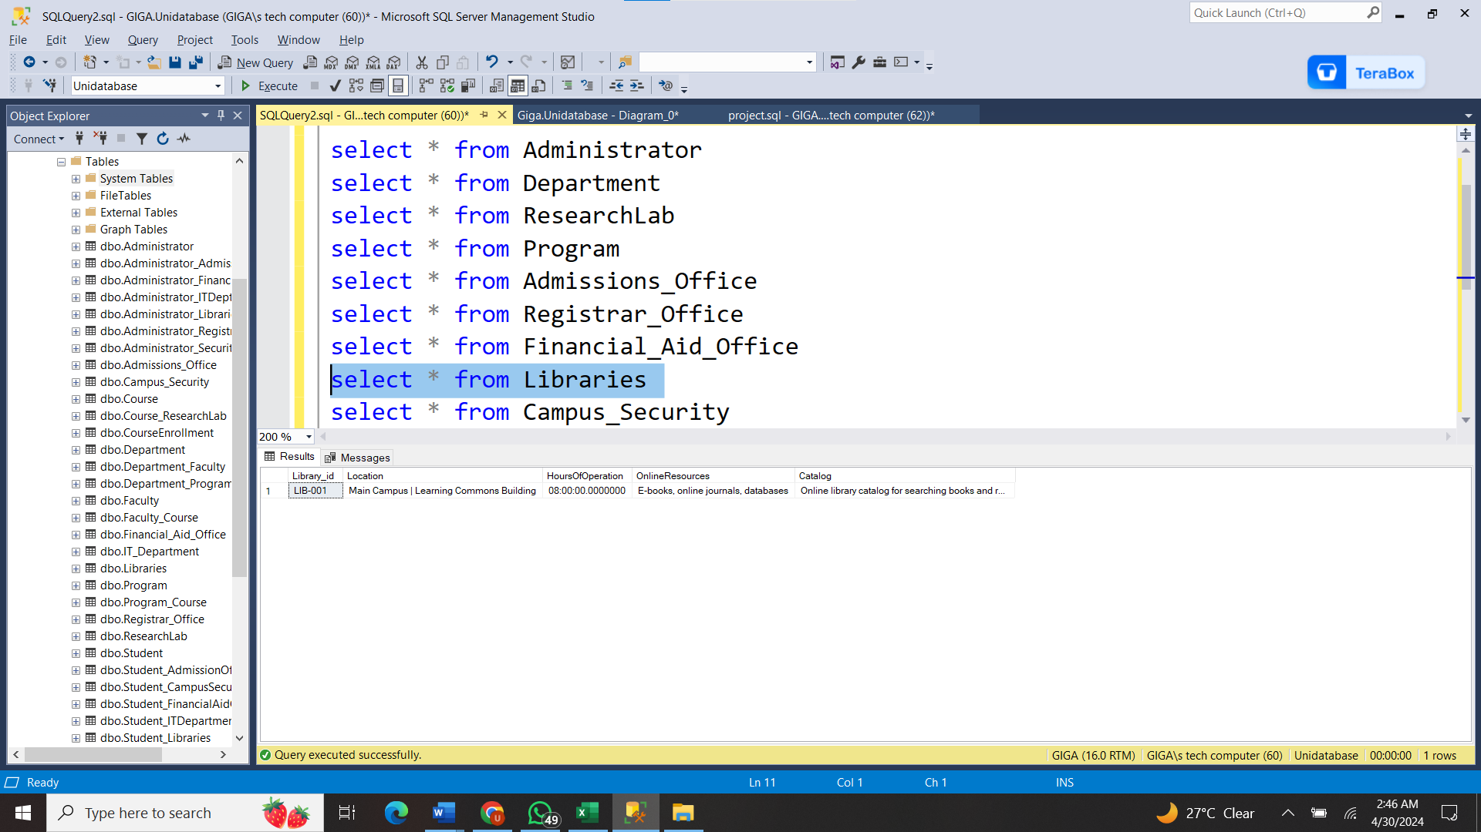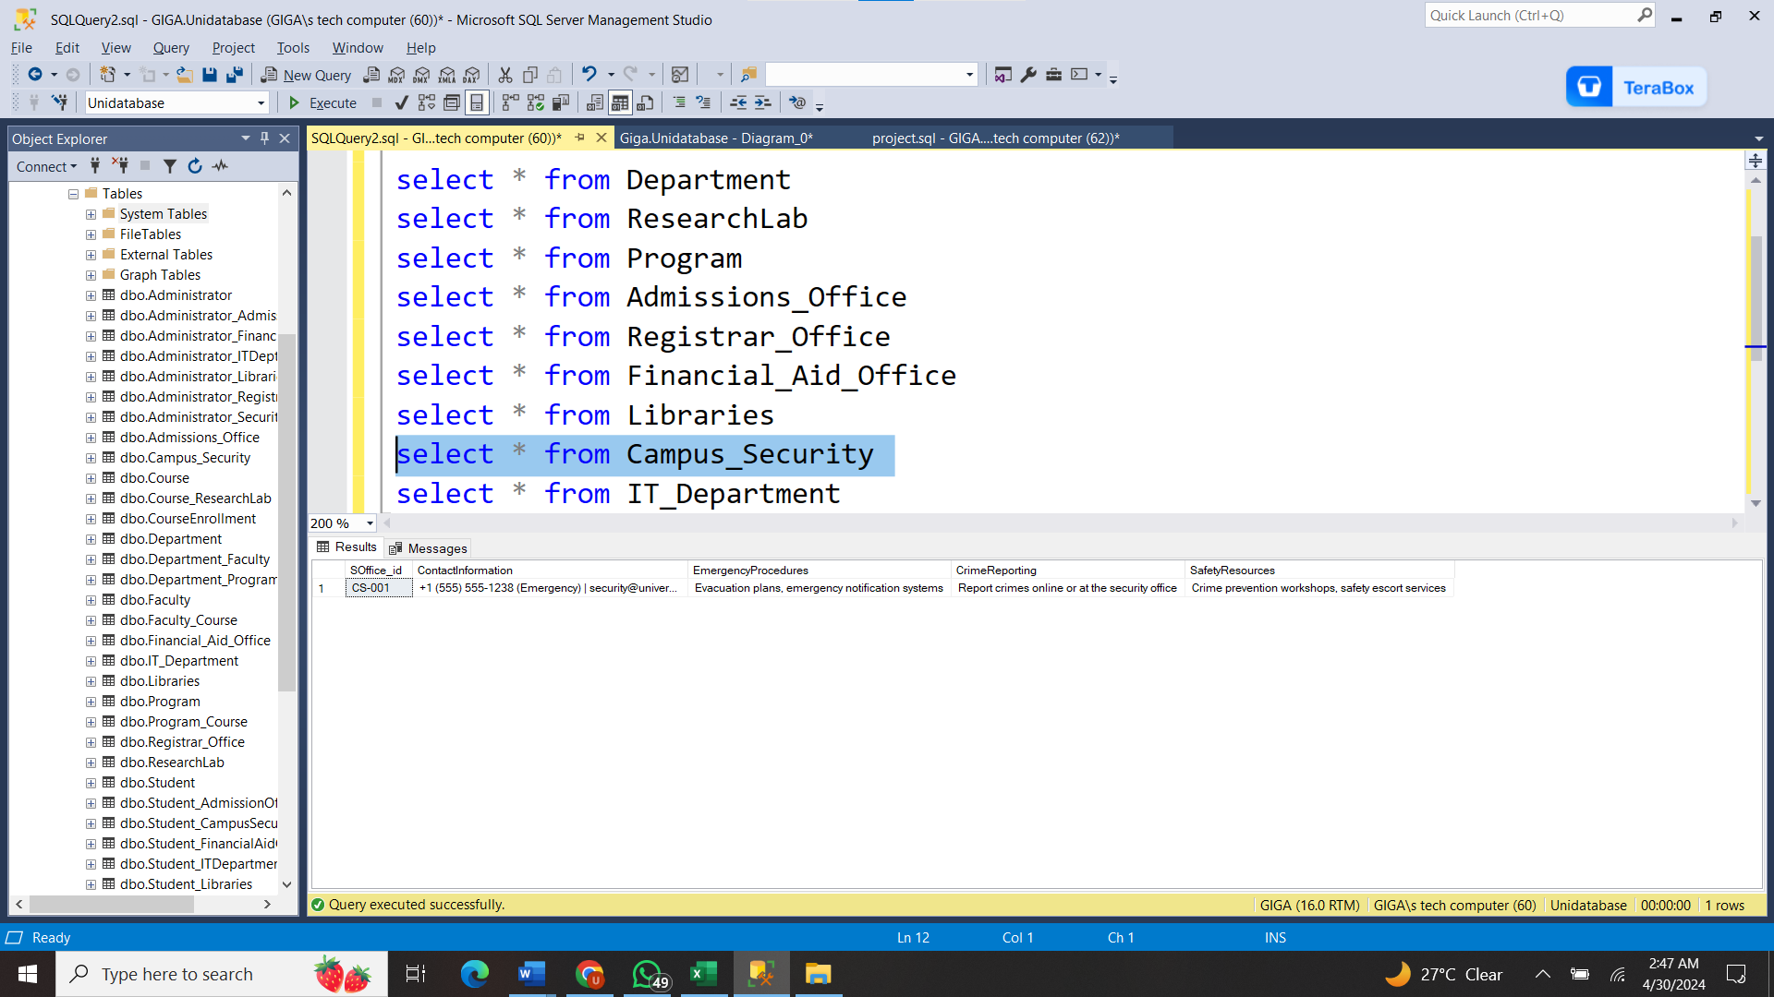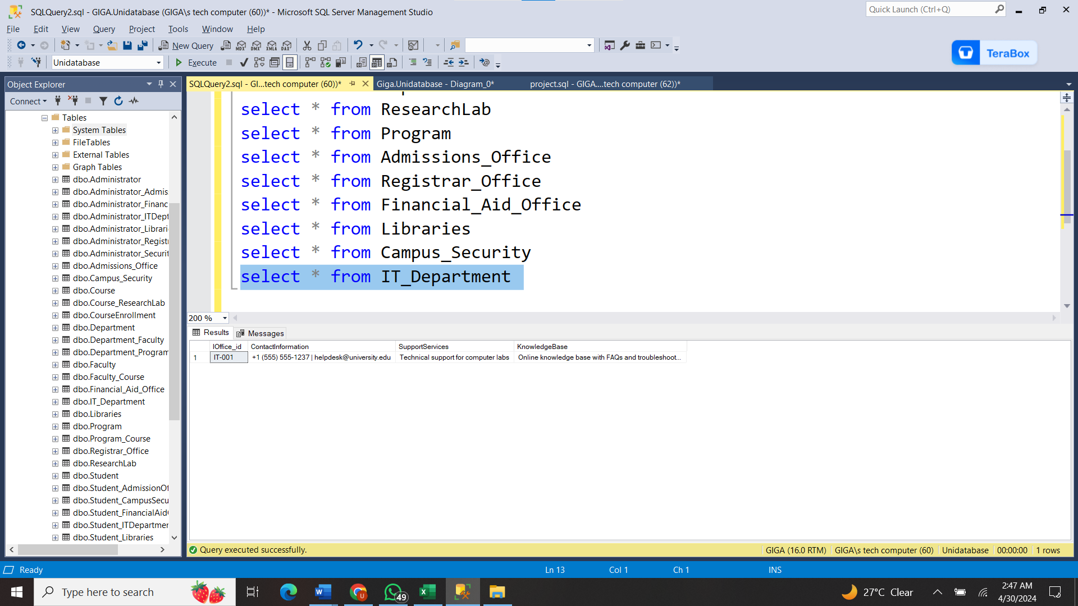

# Entity Relationship Diagram:

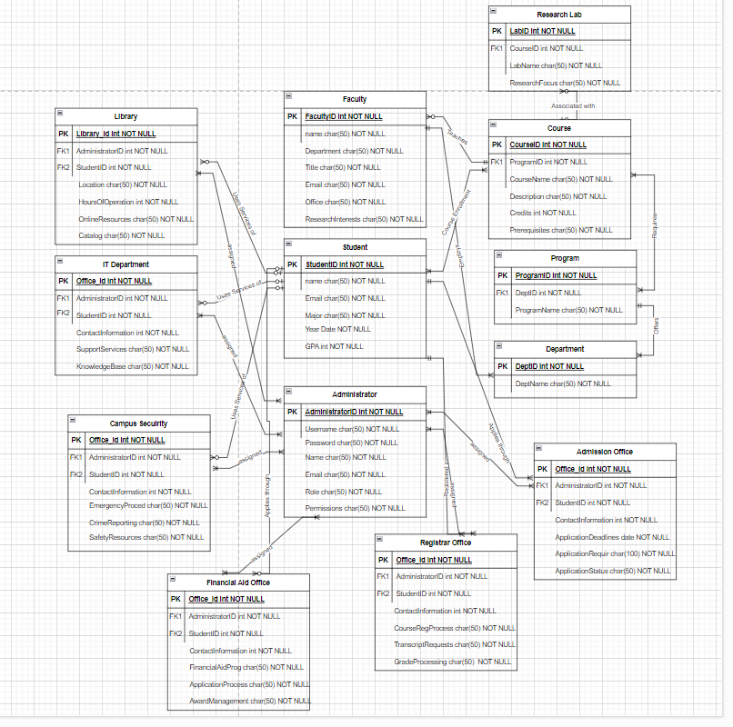

# Normalization:

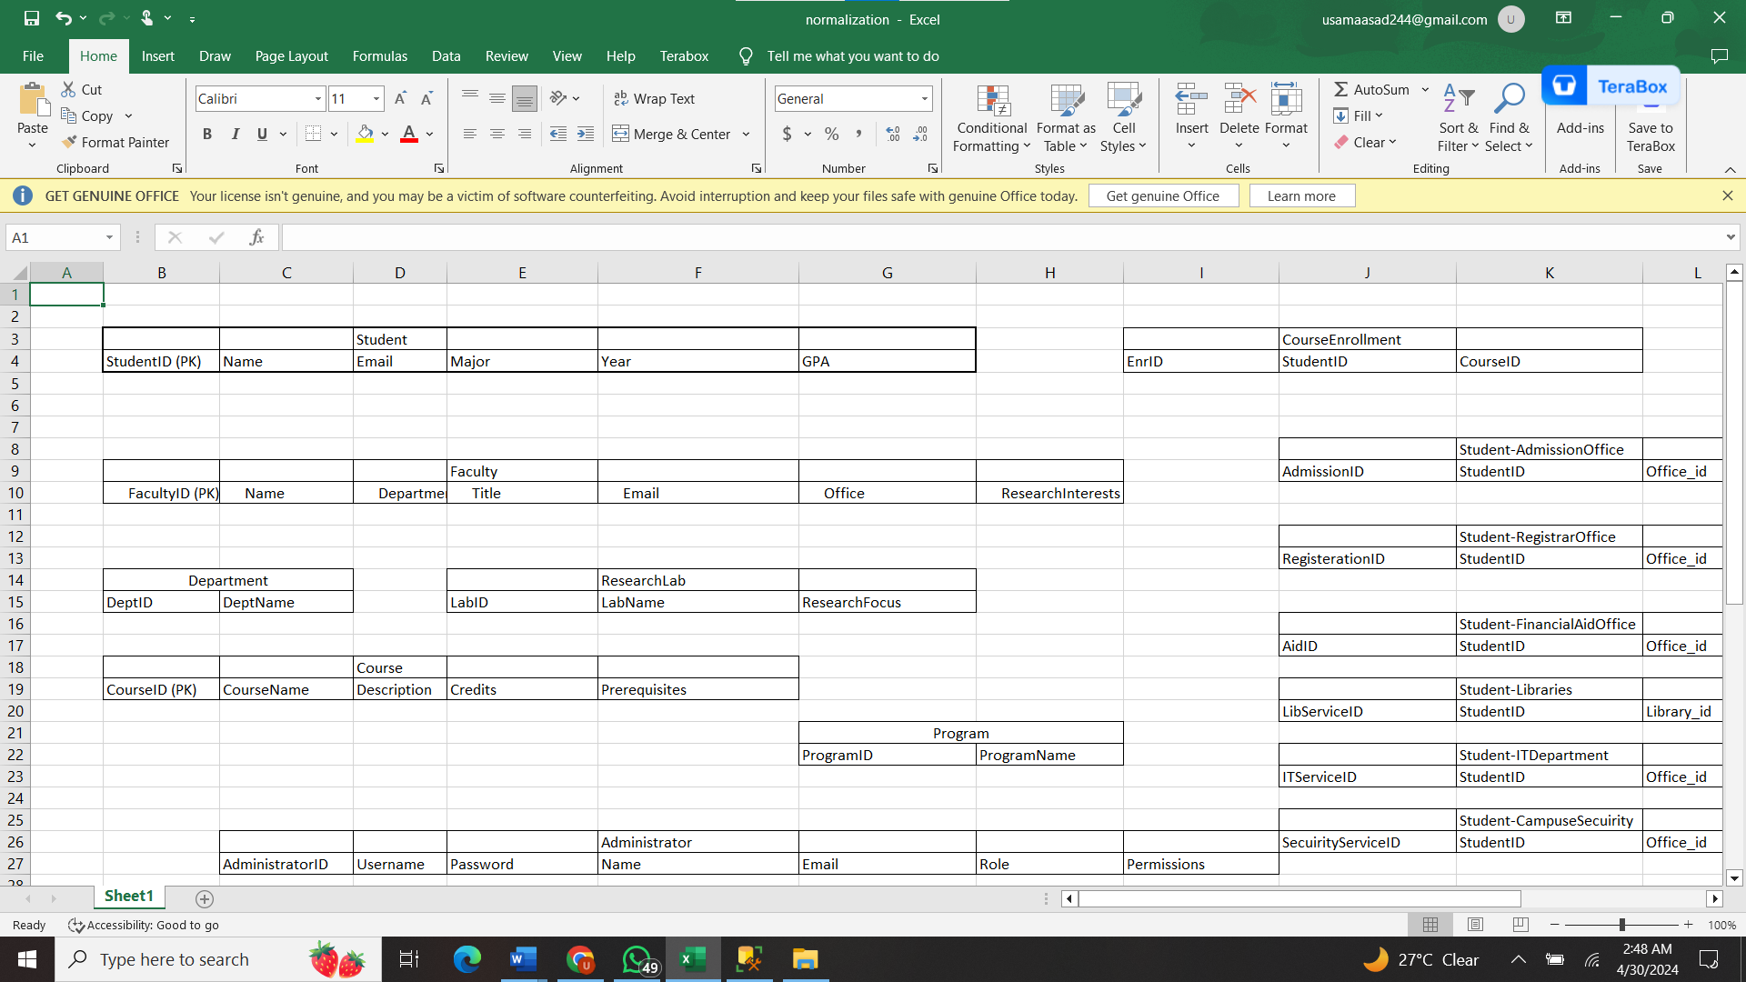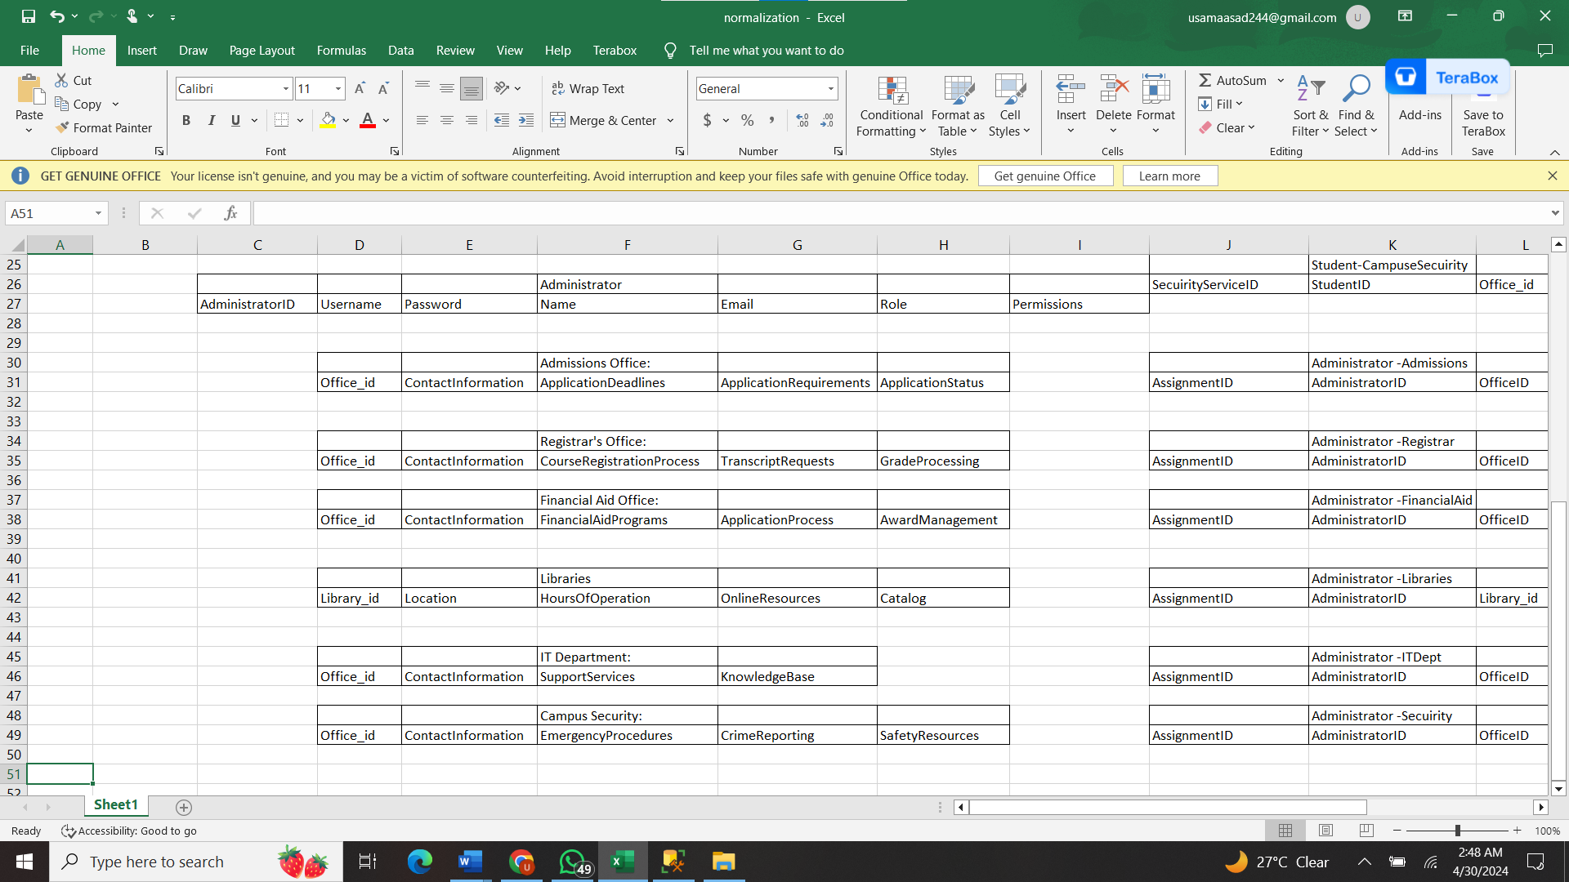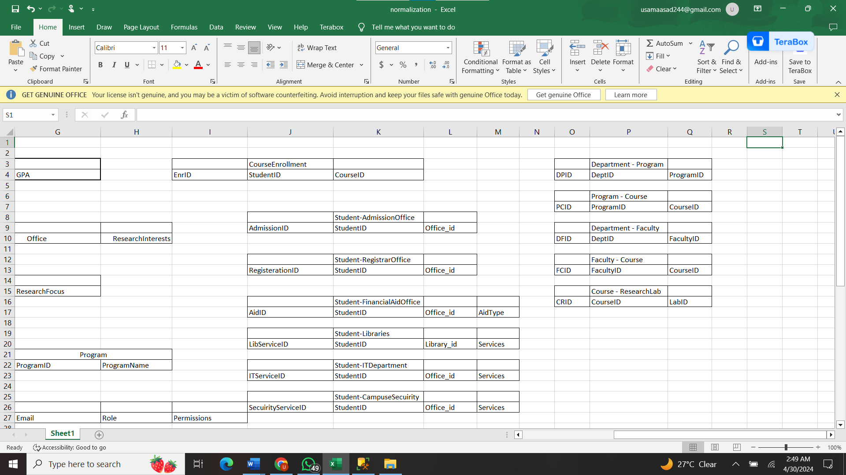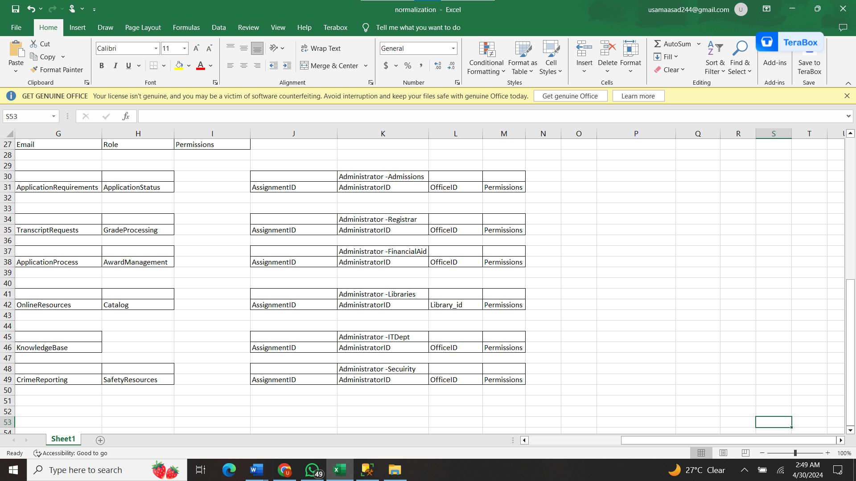

# PL functions

1. **GetStudentInfo (studentID)**

CREATE OR REPLACE FUNCTION GetStudentInfo (studentID IN VARCHAR2)

RETURN StudentInfo%ROWTYPE IS

student_record StudentInfo%ROWTYPE;

BEGIN

SELECT Name, Email, Major INTO student_record FROM Student WHERE StudentID = studentID;

RETURN student_record;

END GetStudentInfo;

/

1. **UpdateOfficeHours (officeID, newHours)**

CREATE OR REPLACE PROCEDURE UpdateOfficeHours (officeID IN VARCHAR2, newHours IN VARCHAR2)

IS

BEGIN

UPDATE Registrar_Office -- Assuming Registrar's office for example

SET CourseRegistrationProcess = newHours

WHERE ROfficeID = officeID;

DBMS_OUTPUT.PUT_LINE('Office hours updated successfully.');

END UpdateOfficeHours;

1. **SearchLibraryResources (keyword)**

CREATE OR REPLACE FUNCTION SearchLibraryResources (keyword IN VARCHAR2)

RETURN SYS_REFCURSOR IS

resource_cursor CURSOR IS

SELECT Title, Author

FROM LibraryResource r

WHERE r.Title LIKE '%'|| keyword ||'%'

OR r.Author LIKE '%'|| keyword ||'%';

OPEN resource_cursor;

RETURN resource_cursor;

END SearchLibraryResources;

# References:

1: W3schools

2: Database Star

3: GeeksForGeeks

4: Codeproject